Activity No. 4.1
Assignment 4.1: Switch Case
Course Code: CPE007 | Program: Computer Engineering
Course Title: Programming Logic and Design | Date Performed: 9-11-25
Section: CPE11S1 | Date Submitted: 9-11-25
Name(s): Paula Esguerra | Instructor: Engr. Jimlord Quejado
6. Output
1. Using switch statement Write a C++ program to input marks of five subjects Physics, Biology and Math. Calculate percentage and grade according to following:
Percentage >= 90% : Grade A
Percentage >= 80% : Grade B
Percentage >= 70% : Grade C
Percentage >= 60% : Grade D
Percentage >= 40% : Grade E
Percentage < 40% : Grade F

_____________________________________________

The output should be similar to the one below:

Physics : 80

Biology : 80

Math : 80

________________

Average is : ____

Grade Level: ____

2. Aside from the code, create a Pseudo code and Flow chart. Use the Activity template for this activity. Please take note that wrong headers of the activity template will result to deductions

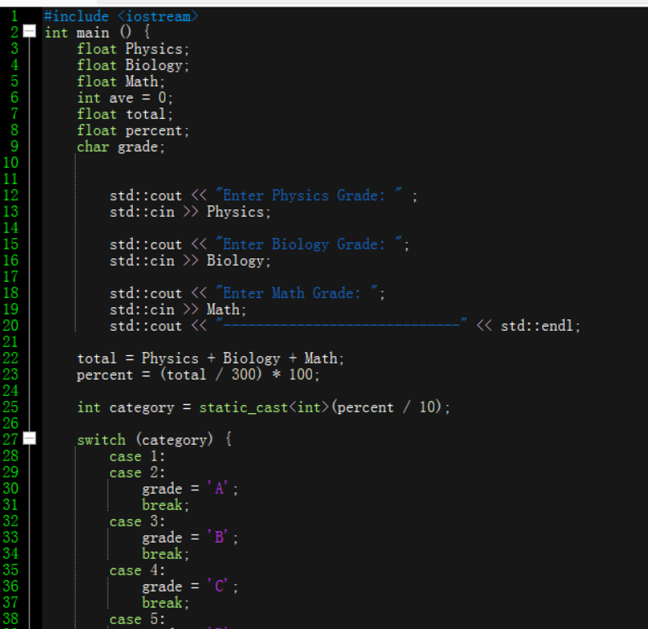
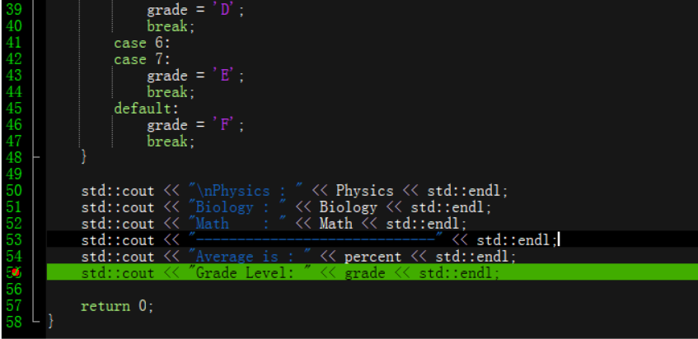
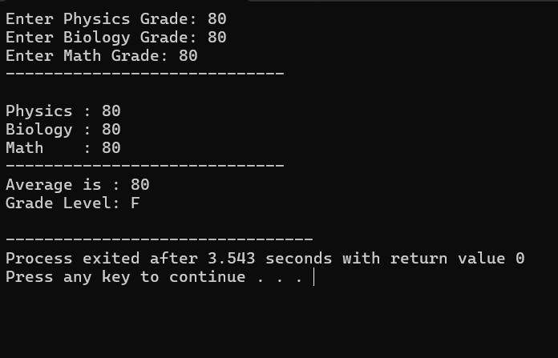

Pseudo Code:
START
INPUT Physics, Biology, Math, total and percent as floating-point numbers
INPUT ave as an integer , equals to zero
INPUT grade as a character
DISPLAY “Enter Physics Grade: “
DISPLAY “Enter Biology Grade: “
DISPLAY “Enter Math Grade: “
CALCULATE total = Physics + Biology + Math
CALCULATE percent as (total / 300) * 100
CALCULATE category by converting percent / 10 to an integer
SWITCH (category)
Case 1 or 2
SET grade A
Case 3
SET grade B
Case 4
SET grade C
Case 5
SET grade D
Case 6 or 7
SET grade E
DEFAULT
Set grade F
DISPLAY “Physics “
DISPLAY “Biology “
DISPLAY “Math “
DISPLAY “Average is”
DISPLAY “Grade Level”
RETURN 0
END
FLOWCHART
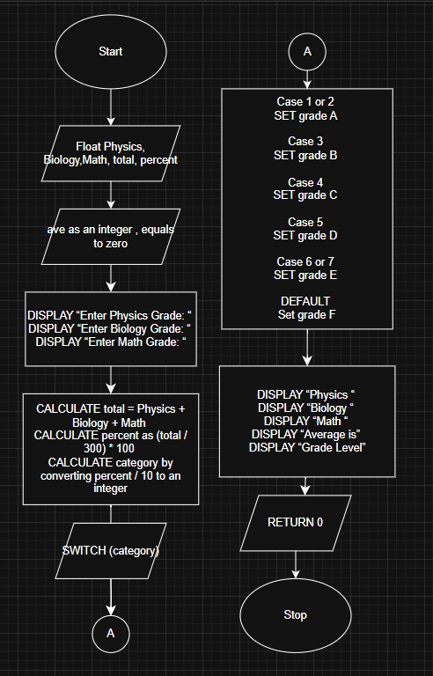

7. Supplementary Activity
8. Conclusion
I learned in this activity, how to use switch, with float, integers. I calculated the grades, I floated the data, so it can hold numbers. I had some trouble on using the Switch.
9. Assessment Rubric

